Steps performed:

1. Host a Ubuntu Virtual Machine using Oracle VM Virtual Box. (5 marks)

As my laptop **Macbook Air M1 model**, “**Oracle VM Virtual Box**” is not compatible with macOS. So, i have used **UTM** as virtual box which is compatible.

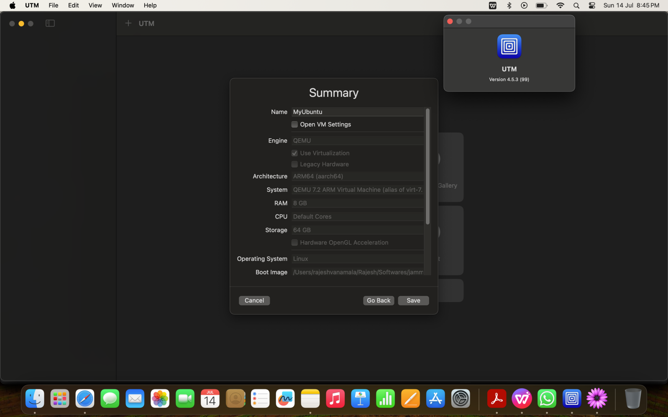

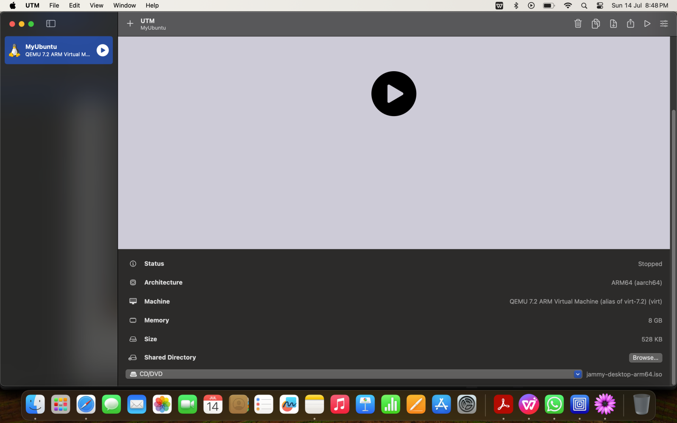

1. Set up Visual Studio code on Ubuntu VM. (5 marks)

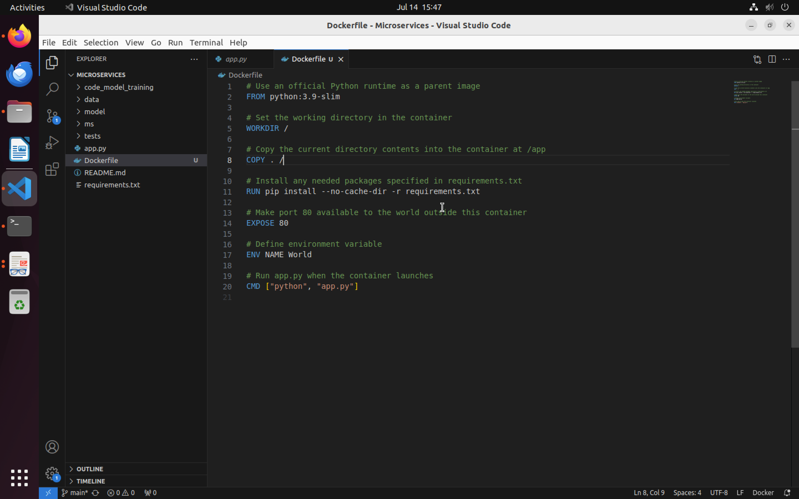

1. Set up Python. (5 marks)

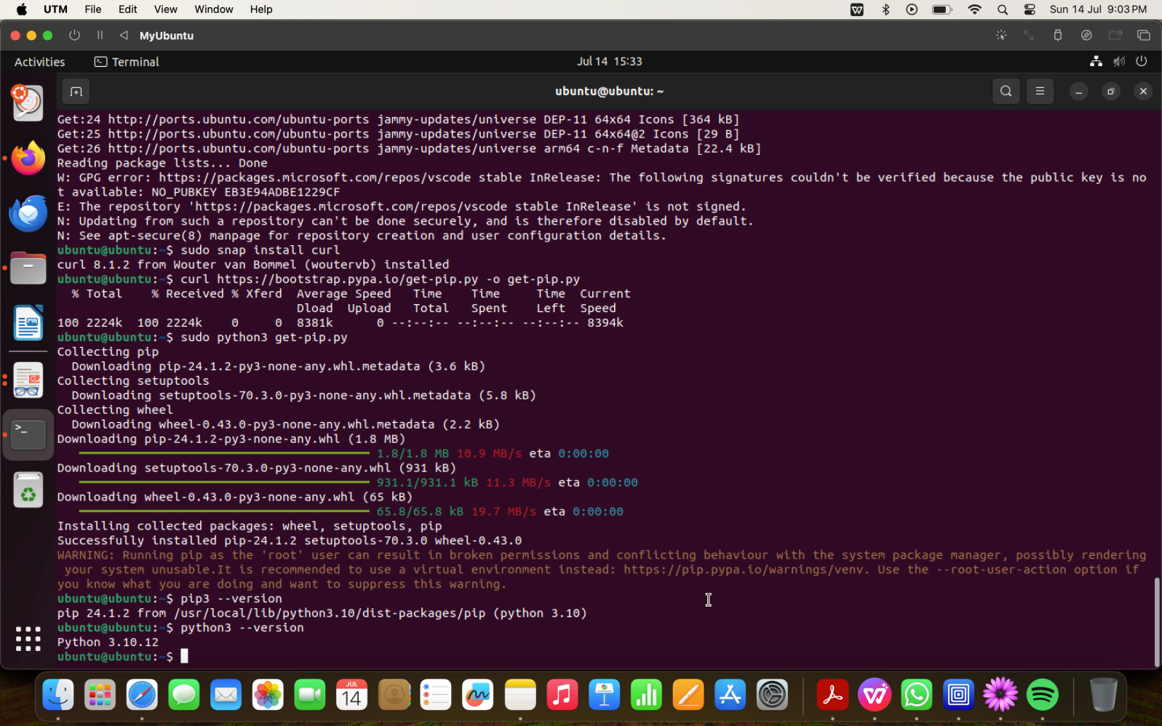

1. Clone this Github repository https://github.com/Vikas098766/Microservices.git (1 mark)

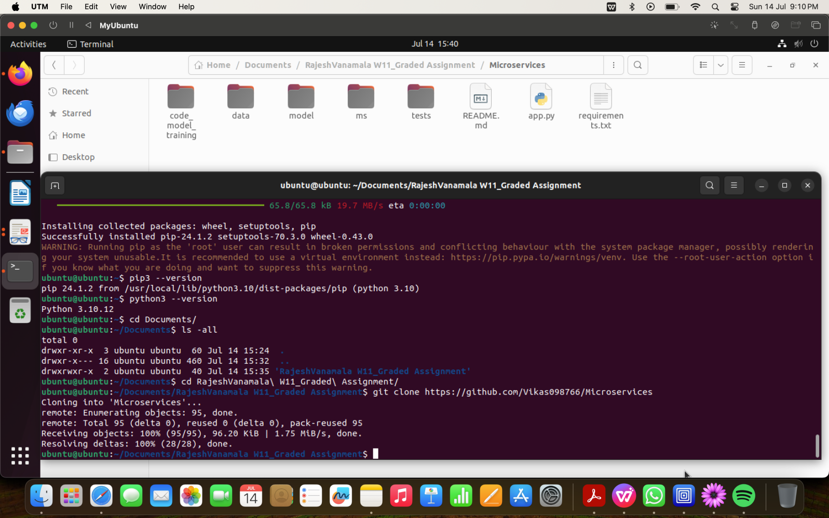

1. Create a Virtual Environment. (1 mark)

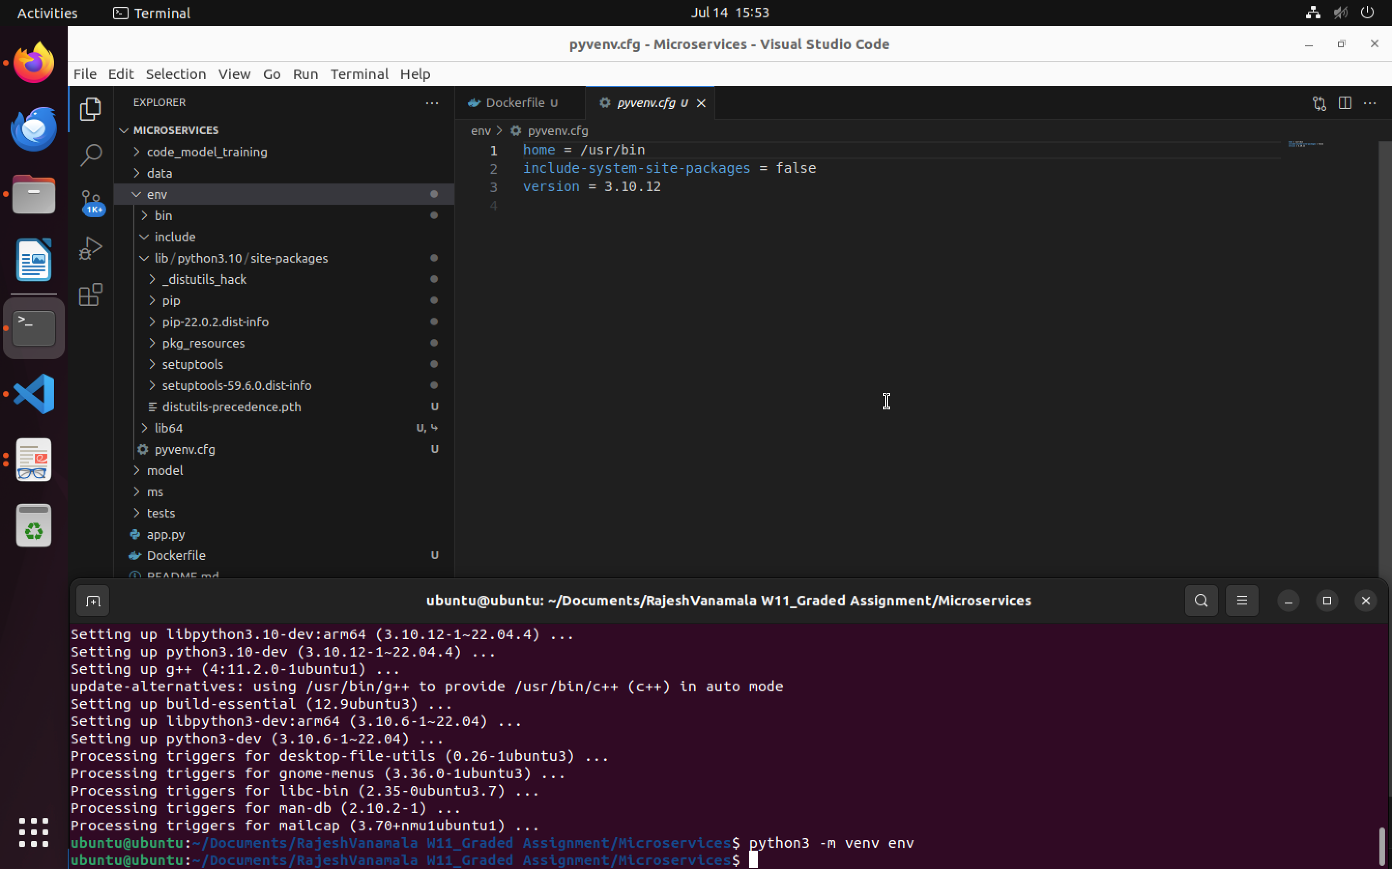

1. Install the dependencies from requirements.txt file. ( 1 mark)

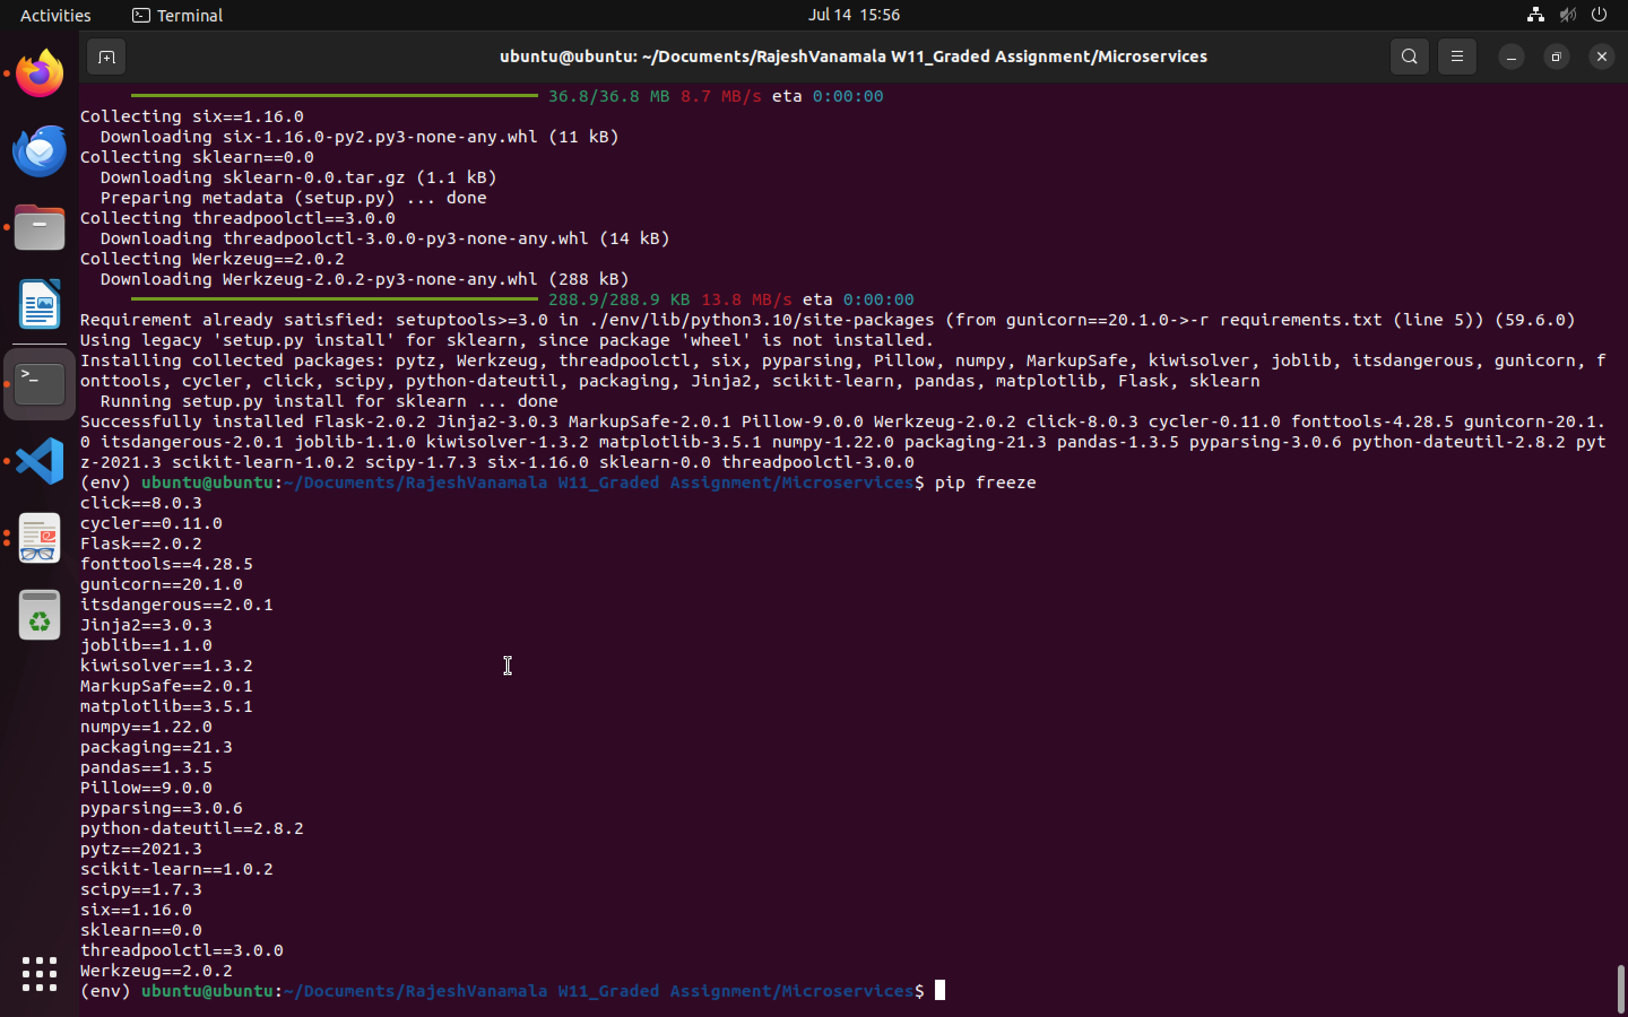

1. Train and save the model. (2 marks)

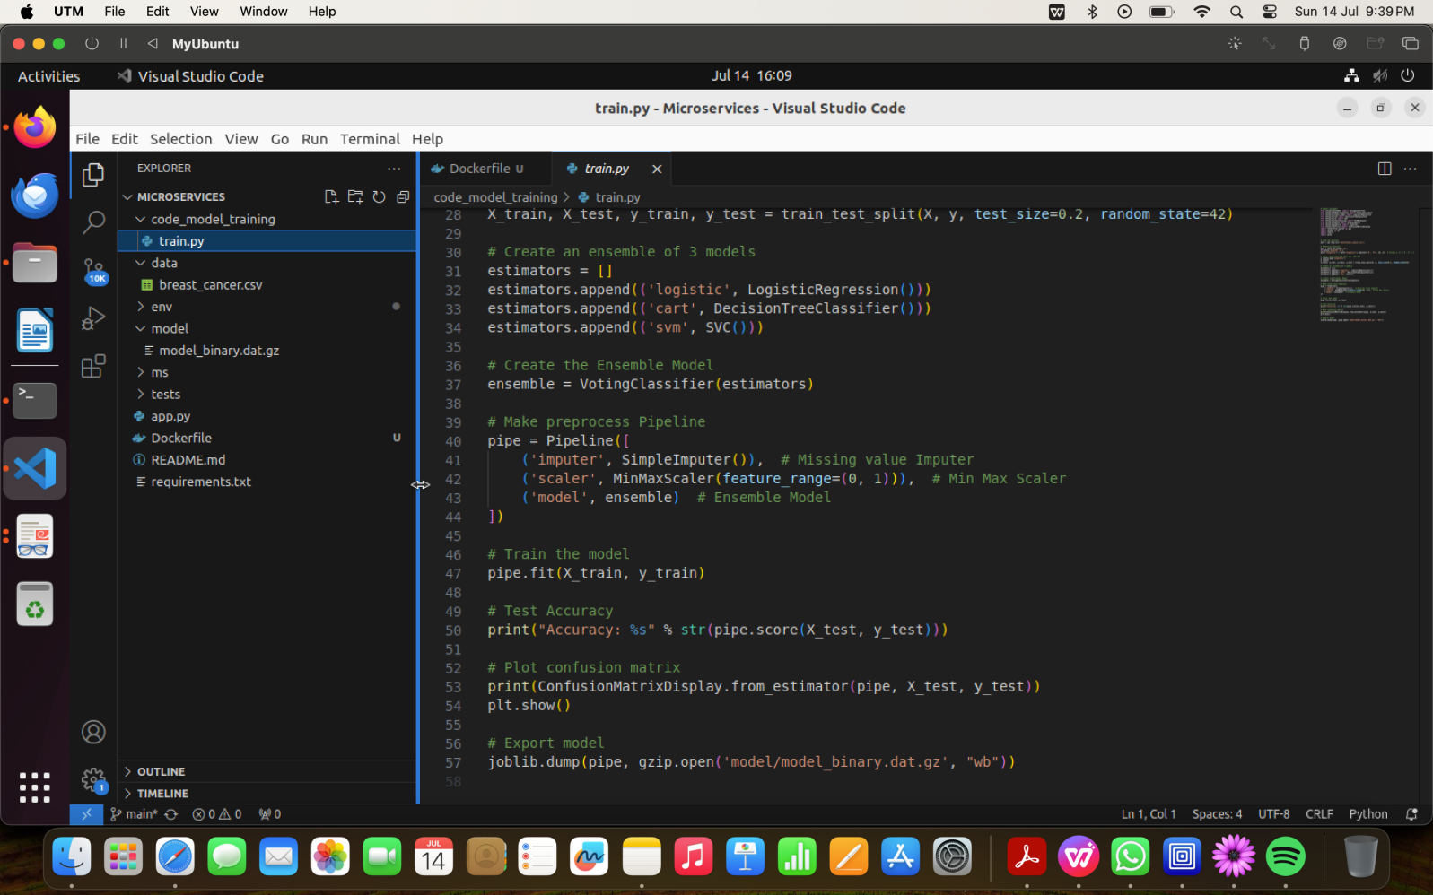

8. Test the Flask web application. (5 marks)

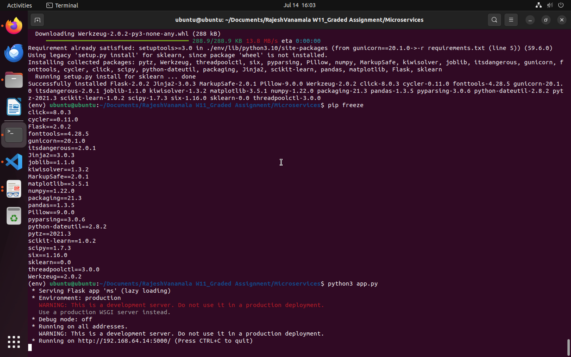

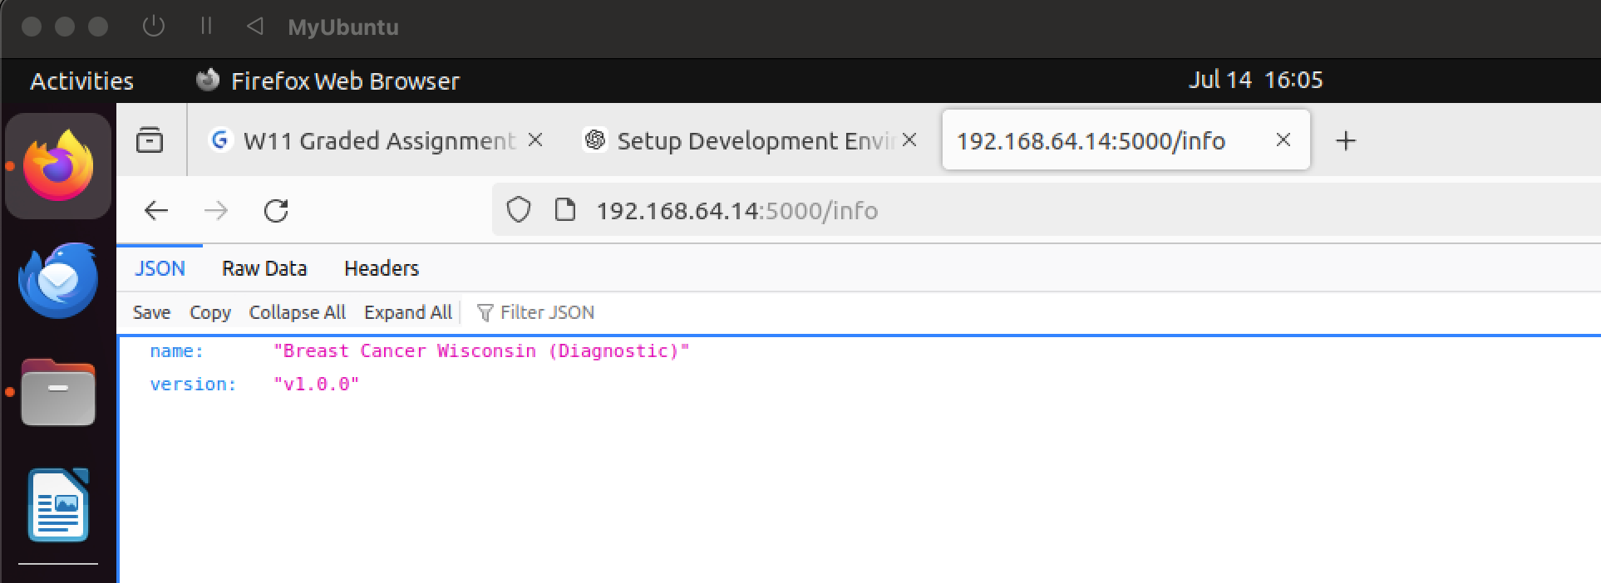

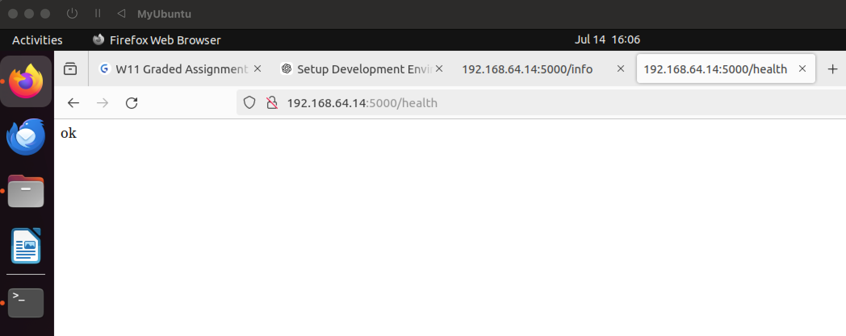

9. Test the application and make predictions using the example calls available in the folder

/tests. (5 marks)

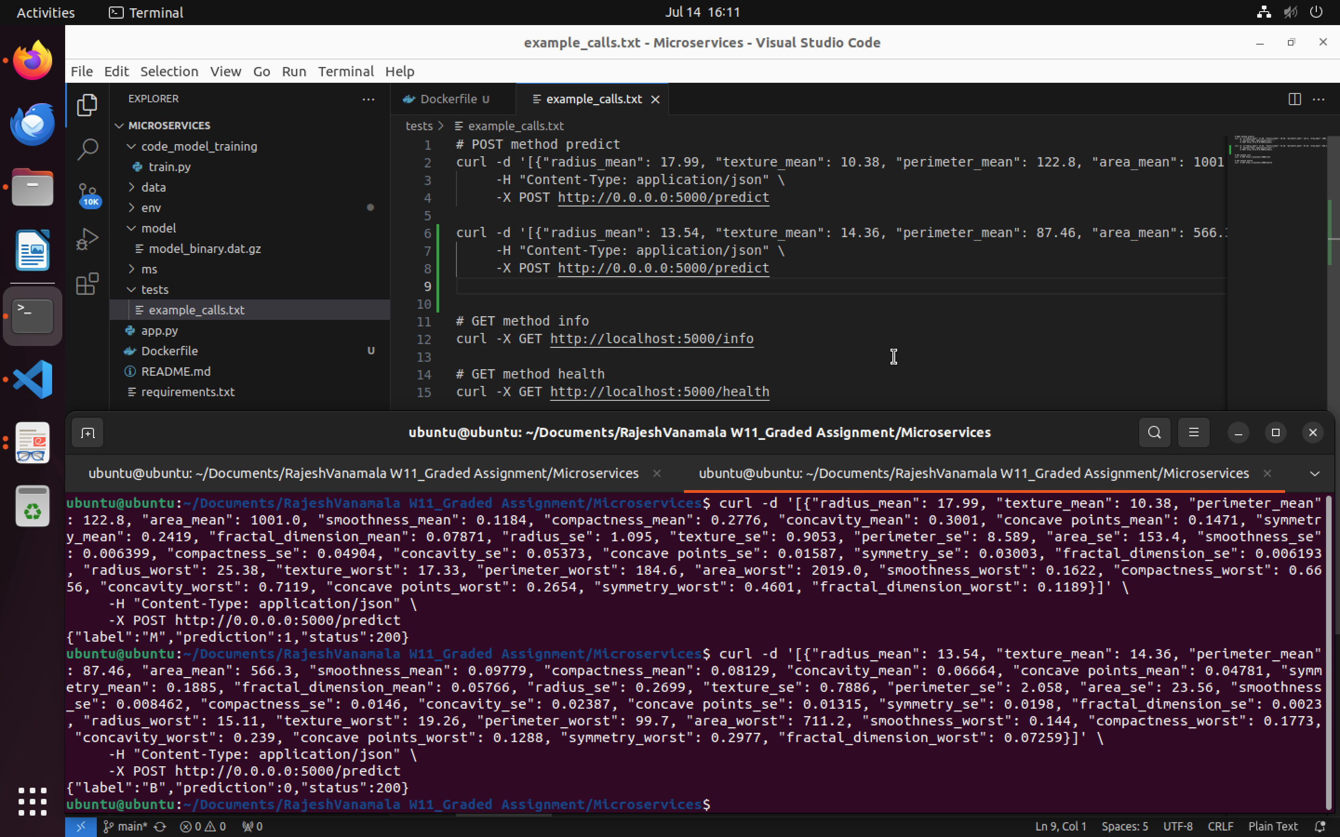

1. Create a docker image containing everything needed to run the application.(10 marks)

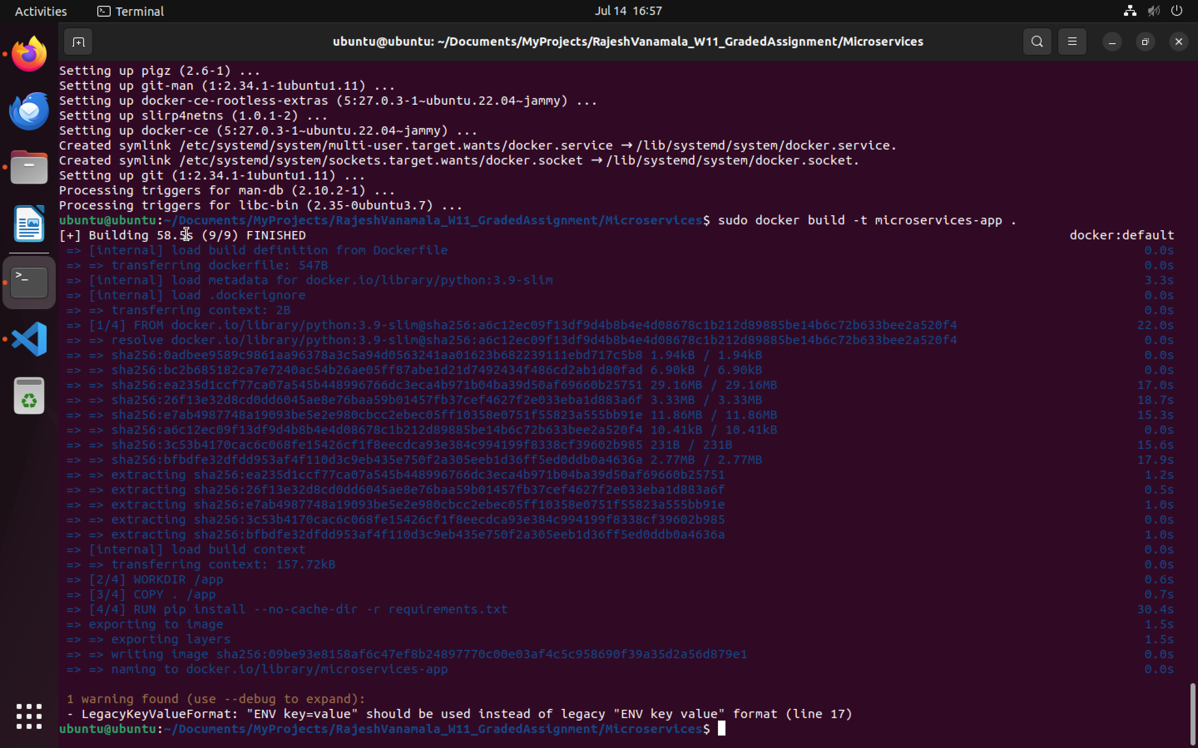

11. Run the containerized application as a prediction service and test it locally by passing

some example calls and get the prediction. (10 marks)

